North Africa regional profile

Figure 1. Financial flows and the components of economic growth in North Africa

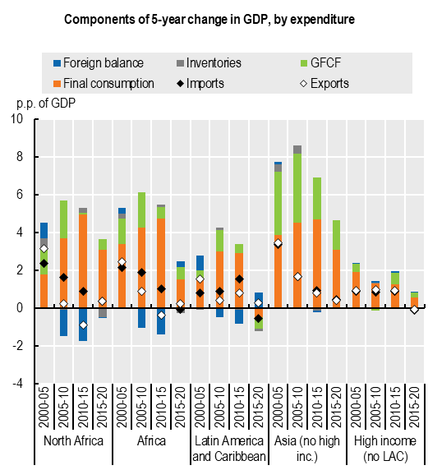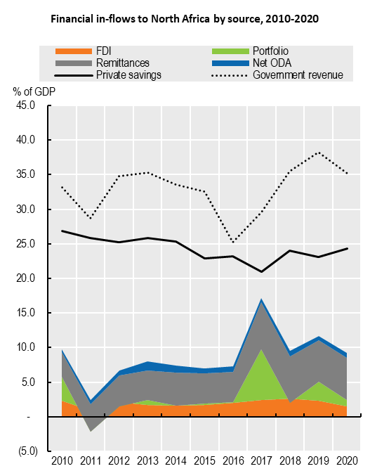

Note: The components of GDP growth are calculated on an annual basis by using real annual GDP growth to estimate the increase in real US dollars. Aggregate figures are calculated by taking the average of the national figures weighted by GDP in PPP dollars. The components of GDP growth over five-year periods were calculated by taking the difference between the geometric average of the annual real GDP growth over the period, and the real GDP growth when setting each component to zero for individual years. Foreign balance is the difference of imports and exports. Imports contribute negatively to GDP. Figures on portfolio in-flows are missing for many countries in North Africa and should be interpreted with caution.

Sources: Authors' calculations based on IMF World Economic Outlook Database April, 2022, www.imf.org/en/Publications/WEO/weo-database/2022/April; Official Development Assistance (ODA) reported by OECD Development Assistance Committee, retrieved September 10, 2022, https://stats-1.oecd.org/Index.aspx?DataSetCode=TABLE2A; World Development Indicators, World Bank, retrieved April 12, 2022, https://data.worldbank.org/products/wdi; World Bank Migration and Remittances Data, World Bank, May 2021.

Figure 2. Greenfield FDI flows into North Africa, by activity, source, and destination, 2017-22

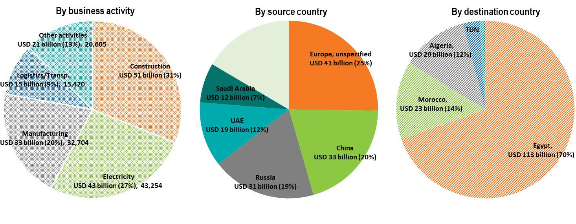

Source: Authors’ calculations based on fDi Markets (database), www.fdiintelligence.com/fdi-markets (retrieved August, 2022).

Recent investment trends in North Africa

Figure 3. Greenfield FDI to North Africa in billions of USD, by business activity, by source country, and destination country

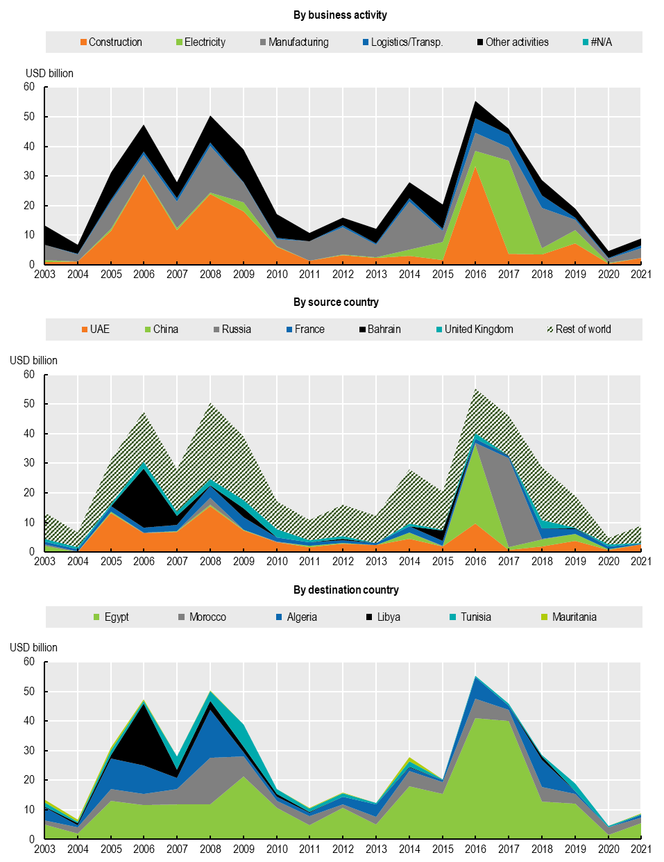

Source: Author's calculations based on fDi Markets (2022).

Figure 4. Annual greenhouse gas emissions from North Africa

Megatonnes of CO2-equivalent emissions

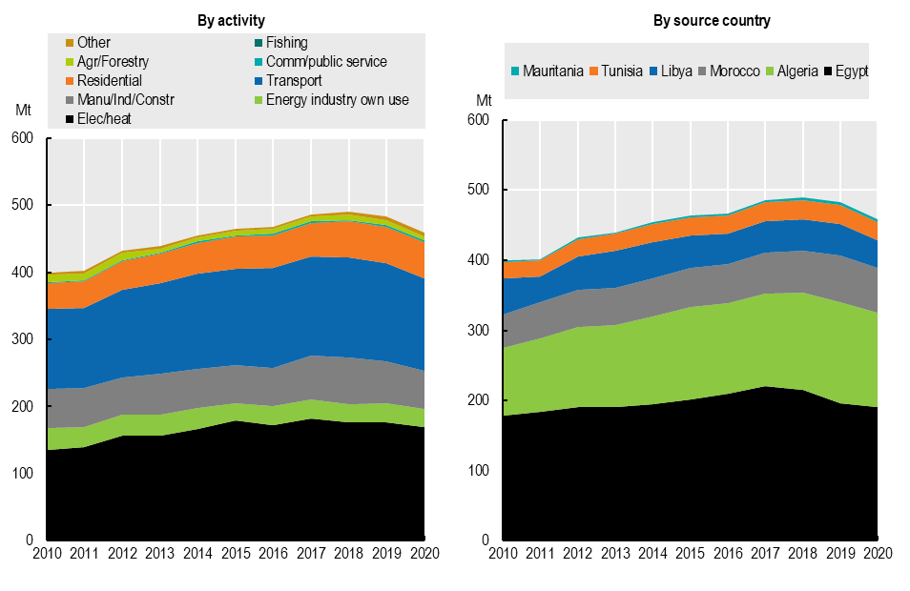

Source: Based on the GHG Emissions from fuel combustion (summary) online dataset, International Energy Agency (IEA) (retrieved 23/09/2022)

Figure 5.Top 10 North African companies, by market capitalisation

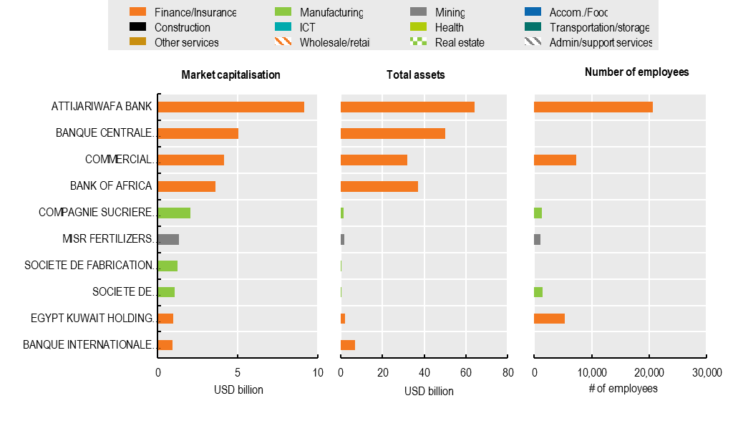

Notes: Companies listed here are the 10 publicly listed private companies with the highest market capitalisation reported within the Orbis database that are based within the region.

Source: Author's calculations based on data from the Orbis Private Companies Database, Bureau van Dijk Electronic Publishing Ltd, www.bvdinfo.com/en-gb/our-products/data/international/orbis.